Vector

What is a Vector
A Vector is a geometric object with the properties of length and direction. We can describe the movement of an Object from one point to another. In Unity, the Vector we would normally use is „Vector3“ with the Variables of x, y and z. X and Y are the direction for the moving while z would be a fix value for most cases.
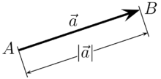
Abbildung 1https://de.wikipedia.org/wiki/Vektor#/media/File:Vektor_zwischen_zwei_Punkten.png

What is a Vector for
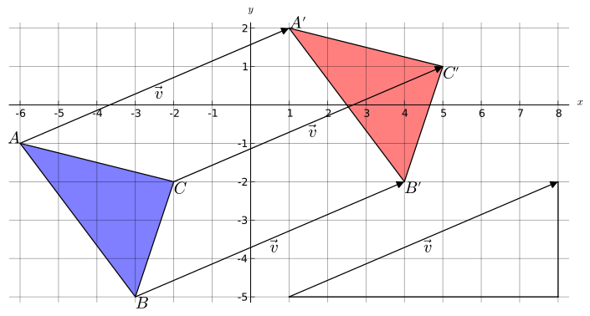
For the movement of an object we can change this vector over time and the object will start moving. For the movement of an ice block that gets pushed by the penguin or by the enemy’s we are having the problem that we have two vectors, the position of the pusher and the position of the ice block, and we need the vector for the moving. To get this vector we must calculate it based on the „SnapTo(Vector3)“ vectors / position that we got and normalize the result. We need the SnapTo-Function to get valid Integer values for the vectors and to get a save way to only move vertical or horizontal.
Abbildung 2https://de.wikipedia.org/wiki/Vektor#/media/File:Vektoren.svg

How to work the Vector
For the SnapTo-Function we just Round the Vectors values for x and y to the next natural number.
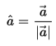
For the normalization of the vector we must give a length of 1 to the vector and should be sure that the vector is not 0. To get the length of 1 we must divide it by its length or multiplied by it reciprocal of the length.
Unity provides 2 types of normalization, one as a function called „public static Vector3 Normalize(Vector3 value);“ and this function will change the vector it’s called from.
To keep the Vector unchanged, we should use the Variable „Vector3.normalized“.

